guest speaker - Hilary Salk

sundaY – March 18th – 4pm
books on the square
471 Angell st, wayland square, providence

“Why I Write, Why I wrote, what I learned”

eavesdropping in oberammergau
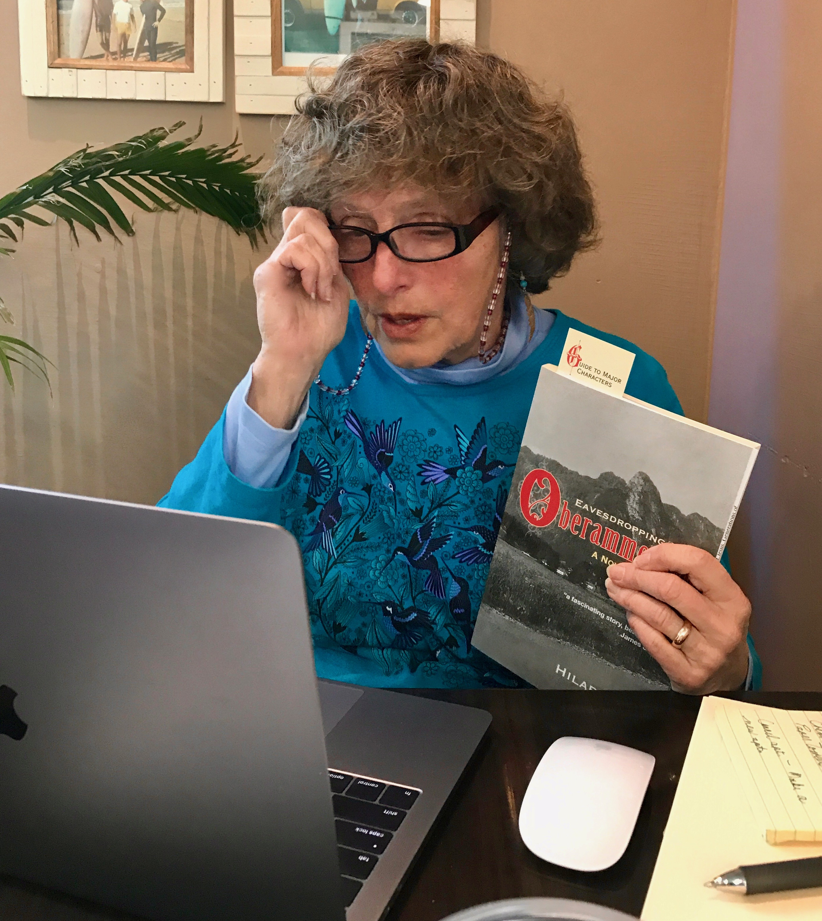
In 2016 Hilary Salk self-published a novel called Eavesdropping in Oberammergau that draws on her experiences as an American Jewish girl living with her parents in Germany three years after the Holocaust. She now asks the questions: Did I feel safe then? Am I safe now?
Hilary Salk has degrees from Brown University and Rhode Island College. She founded the Rhode Island Women’s Health Collective in 1975, ran for Governor in 1982, and worked as a real estate broker in Providence for 25 years.

